|  |
| --- |
| **Church News**  radiYAte Weekend Away  Young adults weekend away is happening Sept 14-16! Our speaker is James Chen. Registrations still open!  Reachout Missions Conference (Sept 8-9 in Katoomba)  God calls all to partake in His great mission, whether you are looking to go short term/long term or still trying to figure out. ReachOut conference is a good way to learn more about missions and different opportunities available.  See PT (from Bankstown) if interested. You can also RSVP on Facebook: <https://www.facebook.com/events/457380904713427/>  Support Gospel work at SWEC!  Generous financial partners are needed to help grow the ministry of Gospel work at SWEC.  Please consider partnering with SWEC by setting up electronic giving.  For information on how to set this up, email [give@swec.org.au](mailto:give@swec.org.au) |

**Offertory Update**

|  |  |  |  |  |  |
| --- | --- | --- | --- | --- | --- |
| March | | | Year To Date | | |
| Actual | Budget | Difference | Actual | Budget | Difference |
| $ | $ | $ | $ | $ | ($) |
|  |  |  |  |  |  |

|  |  |  |  |  |  |  |  |
| --- | --- | --- | --- | --- | --- | --- | --- |
| **Upcoming Events**  August  18th – RICE Rally | **Stay Connected**   |  |  | | --- | --- | |  | fb.com/swechurch | |  | @swechurch | |  | swec.org.au/newsletter | |

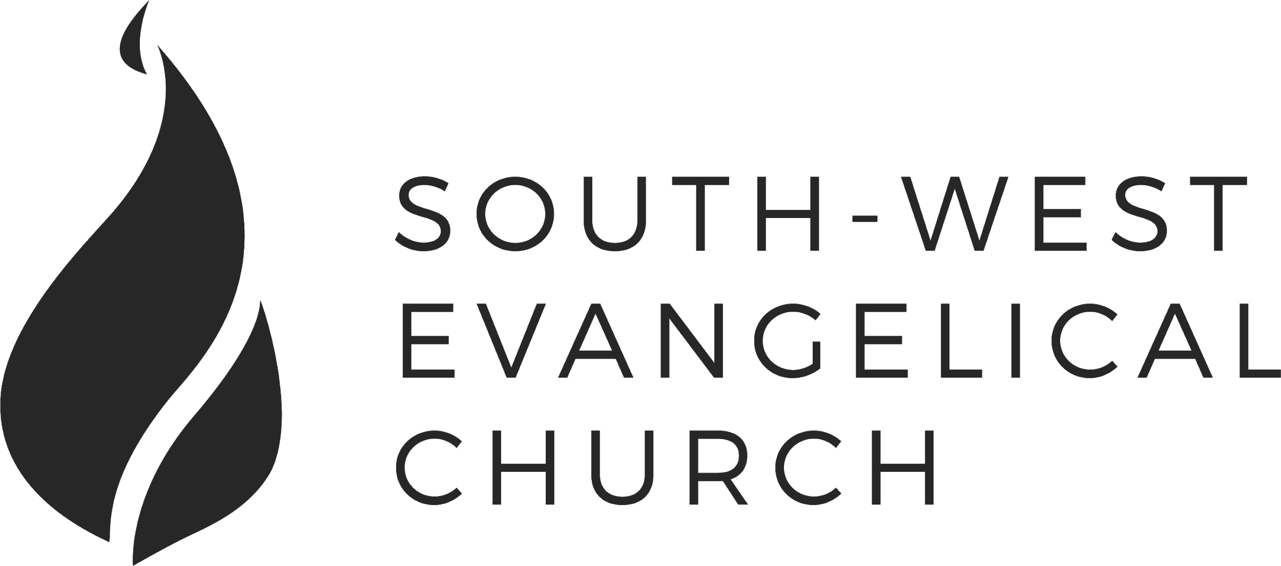

Sunday, 19 August 2018 | 11am English | [www.swec.org.au](http://www.swec.org.au)

Pastor Peter Ko | 0433 493 488 | pko@swec.org.au

What we’ll be doing during our time together

1. Worship

We’ll be worshipping God through song, prayer and by hearing His word.

Today’s confession prayer

Heavenly Father,  
 We praise you for adopting us as your children  
 And making us heirs of eternal life.  
 In your mercy you have washed us from our sins  
 And made us clean in your sight.  
 Yet we still fail to love you as we should and serve you as we ought.  
 Forgive us our sins and renew us by your grace,  
 That we may continue to grow as members of Christ,  
 In whom alone is our salvation.  
 Amen.

Bible reading - 1 Samuel 5:1-8

2. Community

An opportunity to get updated with what’s happening at SWEC!

3. Prayer

We’ll be praying for various needs in our church, the wider community, and the world.

4. God’s Word

Today’s sermon will be given by Peter Ko.

5. Response

An opportunity for us to respond by singing, through holy communion, and by financial giving.

6. Blessing & Sending  
Go with God’s blessing to love and serve him and the world.

|  |  |  |
| --- | --- | --- |
| **Pastors**  Peter Ko (Lead Pastor)  Stephen Fei  Dom Cheung  Karen Ko | **Elders**  Johnson Lee  Andrew Lim  Kirby Wong  Nelson Siu  board@swec.org.au | **Student Pastors**  Andrew Hayes  James Hoey  **Ministry Intern**  Lisa Truong |

[INSERT SERMON TITLE]

[INSERT SERMON OUTLINE]

Today’s Sermon Code:

Zacpages is a digital church tool to follow our sermon outlines, read bible references, take notes and find out more information about our upcoming church events.

Check it out on the Apple App Store, or Google Play Store!

